Chromatography

| **Subject:** Chemistry  **Related Subjects:** Chromatography | **Grade Level(s):**  **Length of Lesson:** | **Type:** Inquiry / Design / Project  **Keywords:** Chromatography, Analytical Chemistry, Molecules |
| --- | --- | --- |

# Lesson Overview

Chromatography is a common technique in analytical chemistry used to separate mixtures. It is also used in crime labs to examine evidence. In chromatography, a test substance is placed onto a medium, and then a solvent is passed through the substance. Some molecules in the test substance will be attracted to the solvent and move up the medium. Different molecules are transported different distances, causing them to separate.

# Lesson Focus

*What is the central question or phenomenon being investigated? What problem are they trying to solve?*

| Lesson Objective(s) | The student will learn about chromatography. |
| --- | --- |

# Lesson Timing

# 

| Time [min] | Description |
| --- | --- |
| 5 | Introduce the Lesson   1. End Goal 2. Primer Questions 3. Key Vocab Words |
| 1 | Role Models in STEM |
| **Engineering Method** | |
| 5 | Real World Example |
| 5 | Hypothesis & Prediction |
| 5 | Brainstorm & Design |
| 20 | Build & Create |
| 10 | Test & Record |
| 5 | Assess & Evaluate |
| 5 | How to improve? |
| 10 | Lesson Cleanup |

| Materials | * Coffee filters * Black felt tip pens * Tape * Cups * Coffee stir sticks * Water * Pencils |
| --- | --- |
| Instructor Prep | 1. Step 1 |
| Related Resources | * List related lessons/ppts etc available from USC or outside, trusted orgs |

# Lesson Plan

## Introduction

1. What is chromatography?
   1. Chromatography is a widely used technique in chemistry for identifying liquids or gases.
   2. It works by separating the compounds in the mixture based on their chemical properties
2. What are molecules?
   1. A group of atoms that make up chemicals.
   2. Pigments in ink are made up of molecules.
   3. Some molecules are bigger or more attracted to water than others.
3. What is variability?
   1. How different data or results are.
   2. Variability is inevitable in experiments.
   3. It is very difficult to get results that are always exactly the same.

## Procedure

1. Provide each student with a coffee filter, a coffee stir stick, a piece of tape, and a cup of water.
2. Have students cut the coffee filter into strips approximately 1 inch by 4 inches
3. Have students tape one strip of coffee filter to a coffee stir stick, then set the stir stick over a cup of water so that the filter strip hangs down, just touching the water.
4. Read the ransom note out loud.
5. Cut 5 strips of test paper from the ransom note, as shown by dashed red lines.
6. To make sure they don’t destroy the evidence, emphasize that when they set up their test, the water should just touch the bottom of the test strip, and not come in contact with the ink. Take one strip and show them a demonstration of how the test should be set up
7. Divide students into 4 groups (one group per table) and let each group test one strip from the ransom note. When the water has moved ¾ of the way up the test strip, remove it from the water and tape it to a piece of plain paper to dry. Label the paper with the heading “ransom note”
8. Tell students that the number assigned to each suspect is also assigned to the pen that suspect had on them when they were found at the museum. To keep track of which test strip goes to which pen, have them number the top of their test strips in pencil. When the test is completed, they can add each strip to their piece of paper, and label each strip on the paper.
9. Once all four strips have been tested, have students compare the ransom note chromatogram to the suspect pens to try to determine who wrote the note.

## Wrap-up

The purpose of the survey is to let us know your opinions about today’s project. Remember there are no right or wrong answers.

|  |  | Strongly Disagree | Disagree | Undecided | Agree | Strongly Agree |
| --- | --- | --- | --- | --- | --- | --- |
| 1 | The project increased my interest in science |  |  |  |  |  |
| 2 | After this project, I am more confident in doing science |  |  |  |  |  |

3. What is chromatography?

4. What are pigments?

5.What does variability mean?

# Lesson Background for Teachers

## Suggested Real-World STEM Connections

# Real World Example

* Chromatography is used in crime labs to examine evidence.
* In the real world, a lot of evidence has to be collected to draw conclusions.

# Hypothesis & Prediction

* The students will investigate which chromatogram corresponds with the pen used for the ransom note.
* Ask students to predict what will happen when water travels up the paper through the ink marks

# Brainstorm & Design

* Have students brainstorm how they could use chromatography to test the suspect’s pens and determine who wrote the note.
* Students must be careful with the only piece of evidence they have (the ransom note).
* To overcome this constraint, they will make sure the water just touches the bottom of the test strip, and does not come in contact with the ink.

# Build & Create

* The students will be creating chromatograms using coffee filters, water, and black ink markers.

# Test & Record

* Students will test 4 different markers by making chromatograms of them and compare these to the chromatogram from the
* Students will do an observational study.

# Assess & Evaluate

* Students will compare their chromatogram results with their classmates and observe variability.

# How to Improve?

* Ask the students what they would improve or change if they were to do it again.

# **Role Model in STEM**

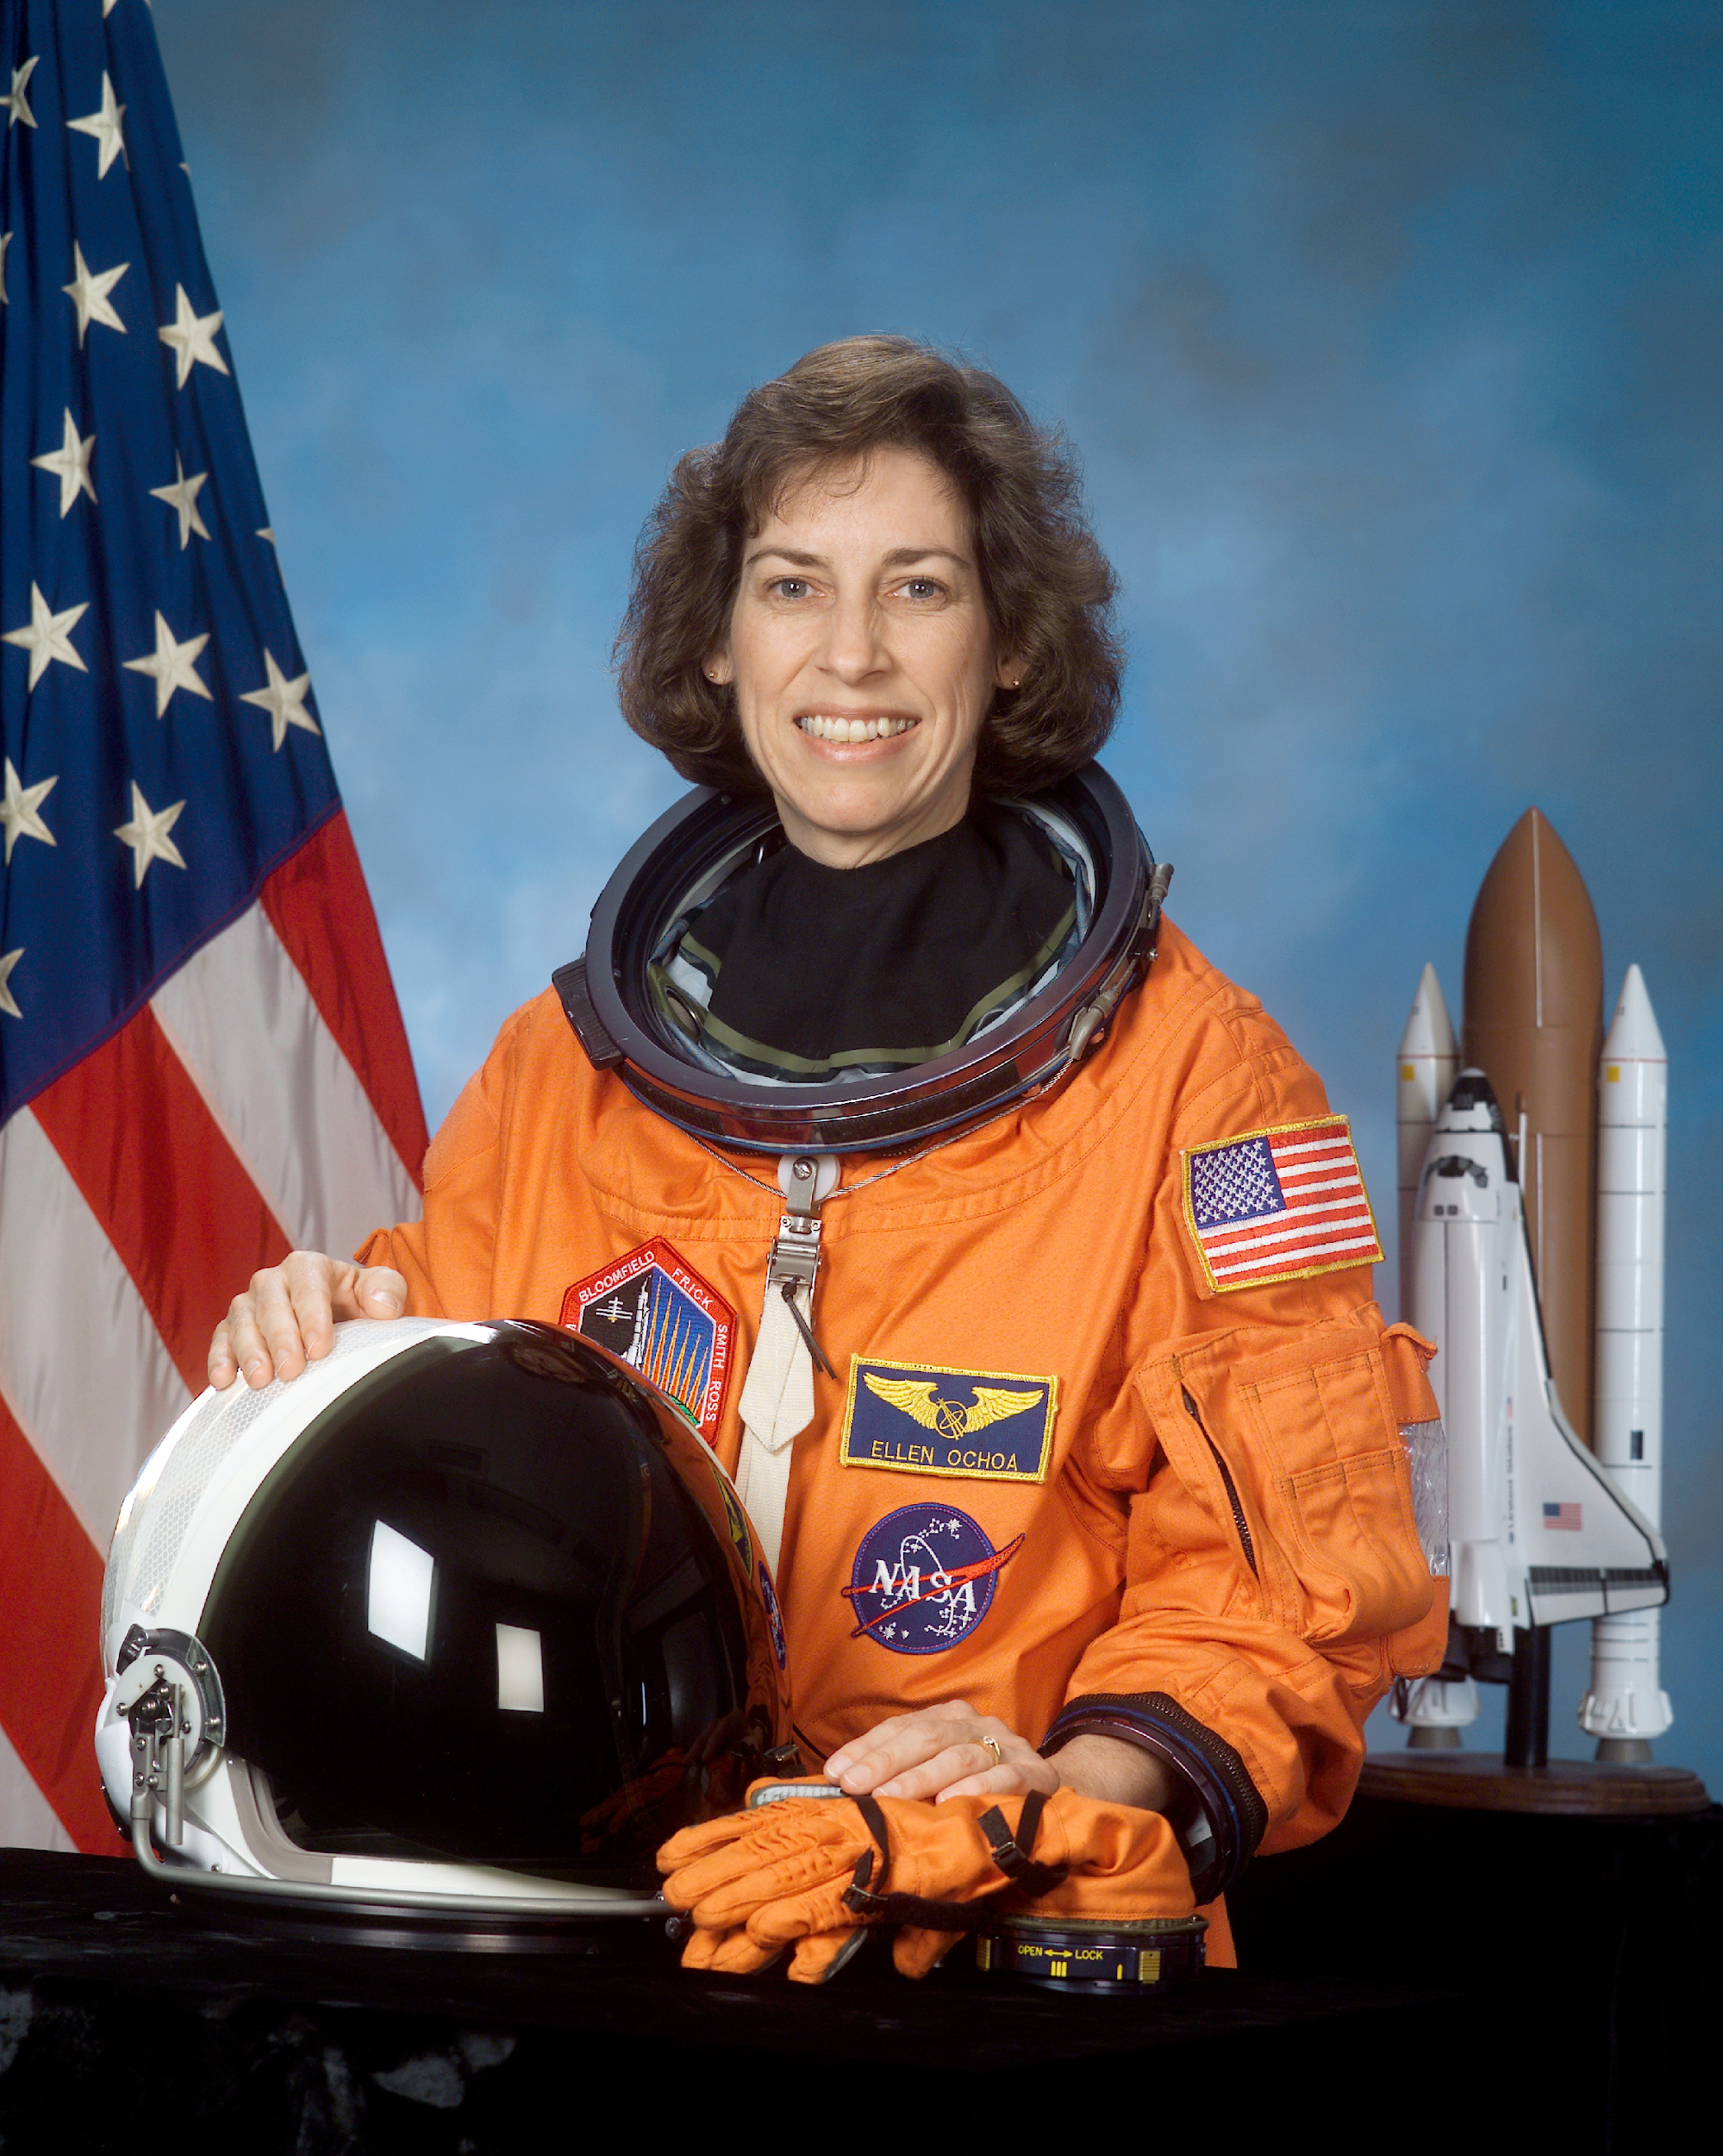

**Name:** Ellen Ochoa

**Years:** 1958

**Quick Facts**

* World’s first female Hispanic astronaut
* She served on a nine-day mission aboard the shuttle Discovery in 1993.
* On board the Space Shuttle were supplies to be used by the first crews living and working on the Space Station and Ellen operated a robot arm that helped transfer four tons of clothing, computers, and medical equipment from one ship to another, 200 miles above Earth.
* Current director of Johnson Space Center.

**Sources:**

1. <https://www.jsc.nasa.gov/Bios/htmlbios/ochoa.pdf>
2. <http://teacher.scholastic.com/activities/hispanic/ochoa.htm>

## Lesson Variations and Options

Include descriptions of alternative methods or ways to present things.

## Explanation

The test substance in this project is ink from felt tip markers. Ink is a mixture of different ingredients, including pigments for color. Black ink contains several pigments mixed together, and each type of black ink is made of distinct and different pigments. In this way, each pen brand has a sort of “fingerprint” in the form of a pattern of colors

## Key Concepts and Vocabulary

* Chromatography
  + A technique used to separate mixtures.
* Pigments
  + Chemicals that make something look a certain color.
* Molecules
  + A group of atoms bonded together. The smallest particle in a chemical element.
* Mixture
  + A material made up of two or more substances.
* Chemical reaction
  + A chemical change that happens when two or more substances combine to form another substance.

## Safety Notes

* Safety instruction